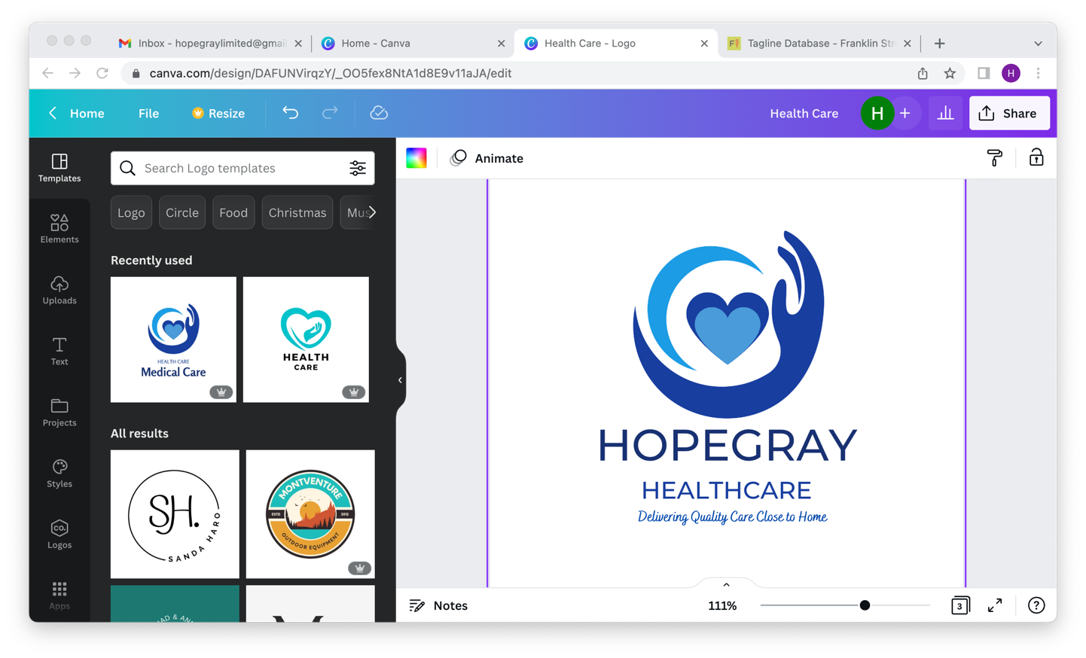

Application Form

PHOTO ID

PLEASE COMPLETE FULLY AND IN CAPITALS

Hopegray Healthcare Ltd recruitment process has a minimum of two stages. The completion of this application form is part of stage one. This application will be reviewed, and a decision made as to whether to proceed to stage two, the interview, based on the information provided.

- Personal Information

Title: | Surname:
Forename(s): | Middle Name:
Previous Names (if applicable): | From: / / To: / /
Date of Birth: | Gender:
Nationality: | NI Number:
Address:  Postcode: | Mobile:
 | Home Tel:
 | Email:
Next of Kin Name:
Address:  Postcode: | Relationship:
 | Home Tel:
 | Mobile:
Are you eligible to work in the UK? YES / NO Expiry Date (if applicable):
Online Enhanced DBS Disclosure Number (if applicable):
Do you hold a full, current driving license? YES / NO Expiry Date:
Do you have any criminal record? YES / NO | If YES, please give details

- Education

Please include your education from secondary school to highest level of education obtained

College / University | Subject / Qualification | Grade / Result | Year obtained

- Employment History

Please provide your employment details starting from current/most recent

Employer: | From: / / | Job title | Reason for leaving
 | To: / /
Duties/Responsibilities:

Employer: | From: / / | Job title | Reason for leaving
 | To: / /
Duties/Responsibilities:

Employer: | From: / / | Job title | Reason for leaving
 | To: / /
Duties/Responsibilities:

Employer: | From: / / | Job title | Reason for leaving
 | To: / /
Duties/Responsibilities:

Employer: | From: / / | Job title | Reason for leaving
 | To: / /
Duties/Responsibilities:

- References

Reference 1

Type of Reference (circle): Employer Educational Personal
Title: | Surname:
Forename(s): | Relationship:
Address:  Postcode: | Job Title:
 | Telephone:
 | Email:

Reference 2

Type of Reference (circle): Employer Educational Personal
Title: | Surname:
Forename(s): | Relationship:
Address:  Postcode: | Job Title:
 | Telephone:
 | Email:

Reference 3

Type of Reference (circle): Employer Educational Personal
Title: | Surname:
Forename(s): | Relationship:
Address:  Postcode: | Job Title:
 | Telephone:
 | Email:

- General Information

During your previous employment, have you ever been dismissed or received disciplinary action taken against you? YES / NO (circle as appropriate)
If YES, please give details:

Please give details below your preference regarding working shifts i.e., Full-time, or Part-time, how many hours are you looking for and when would you like to start?
Details:

To improve our recruitment process, please let us know how you heard about Hopegray Healthcare such as: Facebook, Twitter, Instagram, word of mouth etc.
Details:

Do you require special arrangements to participate in the recruitment process? For instance, large print forms or additional time to complete paperwork etc. YES / NO (circle as appropriate)
If YES, please give details:

Any offer of employment made may be subject to a satisfactory medical report
GP’s Name:

Telephone Number:

Address:

Postcode:
(Your GP will not be contacted without your permission)

- Equality Act 2010

Hopegray Healthcare recognises the benefits of diverse workforce and, hence welcome applications from all parts of the community. We have policy of providing equal opportunities in employment regardless of gender, age, disability, race, belief or religion, sex or sexual orientation and nationality.

Equal opportunities Monitoring Form (circle as appropriate)

Age | 16-19 | 20-29 | 30-39 | 40-49 | 50-59 | 60+

Gender | Male | Female | Prefer not to say

Marital Status | Married | Divorced
 | Single | Widowed
I do not wish to disclose | Civil Partnership | Legally Separated

Sexual Orientation | Heterosexual | Lesbian | Gay
 | Bisexual | Other: | I do not wish to disclose

Religion or Belief | Christian | Muslim | Hindu
 | Atheist | Buddhist | Judaism
 | Sikhism | Other: | I do not wish to disclose

Ethnicity | White
 | British | Irish |  | Welsh |  | Other:
 | Black or Black British
 | African | Caribbean |  | Black British |  | Other:
 | Asian
 | Indian | Pakistani | Bangladeshi |  | Chinese | Other:
 | Mixed
 | White & Black African | White & Black Asian |  | White & Black Caribbean |  | Other:

Do you consider yourself to have a disability | Yes | No | Prefer not to say
Please state the type of impairment that applies to you
Learning Disability | Mental Health condition
Physical Impairment | Sensory Impairment
Long-standing Illness | Other
Notes:

This information will only be used to monitor compliance with the law and best practice in terms of equal opportunity and non-discrimination.

- Personal Statement
(Optional) Please use this section to explain in detail how you meet the requirements of the employee profile (experience, knowledge, skills, and abilities). Please include any additional information not mentioned above.

- Personal Declaration

Please fully read the below and sigh to confirm your understanding and processing of Hopegray Healthcare recruitment process.

I declare that to the best of my knowledge the above information and that submitted in any accompanying documents is correct, and I give permission for any enquiries that need to be made to confirm such matters as qualifications, experience, and dates of employment, and for the release by other people or organisations of such information as may be necessary for that purpose. I give permission for the processing of the personal data contained in this form, and any accompanying attachments, for employment purposes. I understand that any false or misleading information could result in my dismissal.

Name:

Date:

Signature:

Thank you for taking the time to fill this application form, we look forward to hearing from you!

Please email this application and any queries to
contact@hopegrayhealthcare.co.uk

